Community Solar Survey – TEMPLATE

This template “Community Solar Survey” is part of the Community Planning for Solar toolkit designed to help municipalities in Massachusetts and other states proactively plan for solar development in their communities. The survey is part of Step 4 in the planning process, Assess community preferences regarding solar development and financing. This editable template can be used as a starting point for municipalities that want to develop a survey to understand community preferences regarding solar energy. The design, dissemination, and analysis of the survey is described in detail in the Conducting a Community Solar Survey guide (Step 4, Item e), ag.umass.edu/solarplanning4. For more information about the toolkit, visit the UMass Clean Energy Extension (CEE) website, ag.umass.edu/solarplanning.

Attribution: If you use these questions in a survey, please provide a statement of attribution: This survey was developed using a template provided as part of the UMass Clean Energy Extension Community Planning for Solar toolkit (ag.umass.edu/solarplanning).

Project partners and funding
Development of this guide was funded by the U.S. Department of Energy through the National Renewable Energy Laboratory’s Solar Energy Innovation Network cohort program for Solar in Rural Communities, as part of a multi-stakeholder team project to develop a community-informed proactive solar siting and financing model.

The Community Planning for Solar project team included UMass Clean Energy Extension (CEE), the UMass Department of Environmental Conservation, Colby College Department of Environmental Studies, the Massachusetts Department of Energy Resources (DOER), the Massachusetts Department of Agricultural Resources (MDAR), the Pioneer Valley Planning Commission (PVPC), the Franklin Regional Council of Governments (FRCOG), the Western Massachusetts Community Choice Energy Task Force, UMassFive College Credit Union, Northeast Solar, PV Squared, Co-op Power, and the Massachusetts towns of Blandford, Wendell and Westhampton.

In this template, the text highlighted in yellow is intended to be edited. Highlighted text in italics provides directions; non-italic highlighted text should be replaced with numbers or text appropriate for your community’s context.

Community Solar Survey for [insert Municipality Name]
You are being invited to participate in a Community Solar Survey. This is a survey about attitudes towards solar energy in general and preferences for solar energy in [insert Municipality Name]. The responses to this survey will help in the planning process for any future solar growth in [insert Municipality Name]. We have invited all residents of your town to participate in this survey. Anyone over the age of 18 with an address in [insert Municipality Name] is encouraged to participate.
This survey is being conducted by [list who is conducting the survey]. If you have questions about this project or if you have a survey-related problem, you may contact [provide contact information]. The survey is expected to take about # minutes to complete. If you choose to complete the survey, you are free to leave any of the questions unanswered and you may exit the survey at any time.
Your participation is voluntary and your answers are completely confidential. Your name will not be attached to your responses to the survey. All data will be released in summary form and no individual responses will be identifiable. To the best of our ability, all answers in this study will remain confidential. We will minimize any risks by storing all survey data in a computer in a locked room at [location]. After a period of # years following the end of the survey, all identifying information collected as part of this survey will be destroyed.
Your thoughts and opinions are important. Thank you for participating!
Agreeing to Participate in the Survey: By clicking "I Agree" below, you are indicating that you are at least 18 years old, have read this consent form, and agree to participate in this survey. You are free to skip any questions that you choose. You may click "I do not Agree" if you do not wish to take the survey, or simply close this page. You may save a copy of this page for your records.
Do you agree to participate in this survey?
Yes [Takes you to the next question.] No [Exits survey.]
------------------------------
In this survey, when we use the term “solar energy,” we are referring to systems which produce electricity from solar photovoltaic panels, which are also referred to as “solar power,” “solar arrays,” “solar facilities,” “solar development,” or “solar PV.” Here are some examples of solar energy projects. Solar energy projects are often described in terms of their size in kilowatts (kW) or mega-watts (MW), 1 MW = 1000 kW.
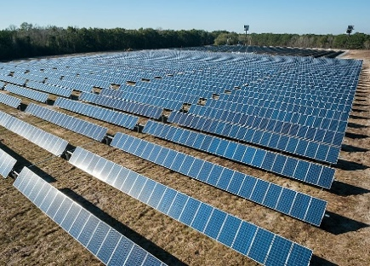
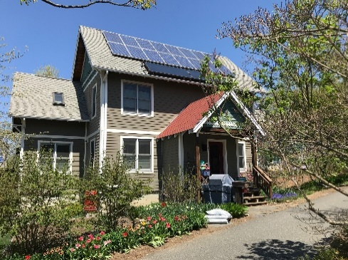
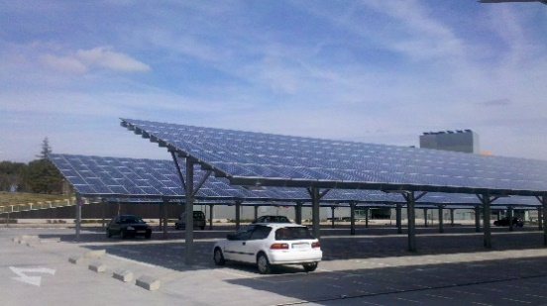
Large, ground-mounted solar
(about 1000 kW – or 1 MW - on 5 acres of land, enough to power 100 homes)
Residential rooftop solar
(about 10 kW on one roof, enough to power 1 home)
Solar parking canopy
(about 100 kW on a half-acre parking lot, enough to power 10 homes)

Your opinions on solar and renewable energy

Solar energy is growing significantly in the United States. Many states, including [insert name of state], have set policy goals to increase solar energy in order to reduce pollution from fossil fuel power plants. In this study, we aim to understand your attitudes about solar energy in general, and your preferences for future solar locally.

- What is your general attitude toward solar energy?
□ Very positive □ Positive □ Neutral □ Negative □ Very negative

- What is your attitude toward solar energy currently installed in [insert name of municipality]?
□ Very positive □ Positive □ Neutral □ Negative □ Very negative

- To what extent do you agree or disagree that the following should be a priority for state or local policy makers: (check one box on each line)

 | Strongly Disagree | Disagree | Neutral | Agree | Strongly Agree
Energy conservation by residents, municipal governments, and businesses | □ | □ | □ | □ | □
Encouraging development of solar energy in the state of [insert State Name] | □ | □ | □ | □ | □
Encouraging development of solar energy in [insert region name] | □ | □ | □ | □ | □
Encouraging development of solar energy in [insert Municipality Name] | □ | □ | □ | □ | □
Encouraging development of solar energy in [insert Municipality Name] that is owned by the town or community members | □ | □ | □ | □ | □
Encouraging local residents to install household solar energy systems | □ | □ | □ | □ | □
Encouraging solar energy in other places to offset energy usage in my community | □ | □ | □ | □ | □
Encouraging development of [insert alternative renewable energy source, for example: offshore wind energy] in the state of [insert State Name] | □ | □ | □ | □ | □
Encouraging development of [insert fossil fuel source, for example: natural gas generation] in the state of [insert State Name] | □ | □ | □ | □ | □

In the next section, we will ask about solar energy in your community. It may be installed on house rooftops - or sometimes in a residential yard - to contribute towards a family’s energy needs. It also may be a larger project on a roof, over a parking lot, or on the ground, that provides more energy than one household needs.

- What is your attitude toward solar energy that is installed on house rooftops?
□ Very positive □ Positive □ Neutral □ Negative □ Very negative

- What is your attitude toward solar energy that is installed in a residential yard to serve that household’s electricity needs?
□ Very positive □ Positive □ Neutral □ Negative □ Very negative

- Do you have solar panels installed at your home?
□ No (continue to question 7) □ Yes (skip questions 7 & 8 and go to the section on Large, Ground-mounted solar in the next section)

- Are you interested in installing solar at your home?
□ No □ Yes □ Not sure

- Please indicate the reason(s) you do not have solar at your home. Please check all that apply.

□ I am not interested.
□ I’ve had, or am aware of, negative experiences
with solar energy.
□ I don’t trust solar developers to work in my best interest.
□ I don’t trust my utility to work in my best interest.
□ I don’t know enough about my options.
□ The upfront cost is too high.
□ Paying my electricity bill is cheaper than paying for solar panels.
□ My property is too shaded to allow for solar panels.
□ I am concerned that solar on my roof will be a safety hazard.
□ I don’t own the property.
□ I am interested, but I need to wait until the next time my roof is replaced.
□ I am interested, but haven’t found the time.
□ Other:___________________________

Large, Ground-Mounted Solar:

These projects are large enough to generate electricity for dozens or hundreds of households. Many systems like this exist in [insert name of region or State]. These projects are an assembly of many solar panels connected together, installed on the ground, on various types of land, such as the images below.
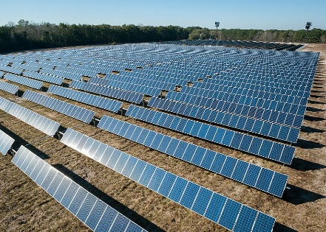
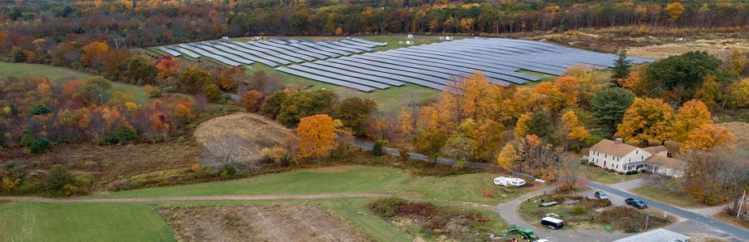
(Source: https://www.wbur.org)
- What is your attitude toward large, ground-mounted solar energy in general?
□ Very positive □ Positive □ Neutral □ Negative □ Very negative

- What is your attitude toward large, ground-mounted solar energy in [insert name of municipality]?
□ Very positive □ Positive □ Neutral □ Negative □ Very negative

- In general, do you believe development of large, ground-mounted solar energy should be:
□ Encouraged and promoted □ Allowed but not promoted □ Allowed and promoted in appropriate circumstances □ Prohibited in all instances
□ Not sure
- To what extent do you agree or disagree that the process of large, ground-mounted solar energy development in your town has been fair?
□ Strongly agree □ Somewhat disagree
□ Somewhat agree □ Strongly disagree
□ Neither agree or disagree □ Not sure

The next set of questions will ask you about your thoughts regarding future solar energy in your community.
[Insert name of state or region] is considering setting a goal of X% renewable electricity by [year], in order to reduce pollution from fossil fuel power plants. This will mean that large amounts of renewable energy will be needed, including solar energy. To meet this goal, many communities in [Insert name of state or region] will see proposals for new renewable energy development, including large-scale solar energy.

- I think our town should invest in solar energy projects on municipal buildings or parking lots for municipal electricity needs.
□ Yes □ No □ It depends: _______________________________

- Which of the following types of community involvement would you like to see if a large-scale solar energy project was being planned in [insert name of municipality]?
[Select all that apply]
□ Information should be shared at public meetings
□ Community members should have the opportunity to review and comment on the siting and design
□ Community members or the municipality should have the opportunity to communicate concerns directly to the solar project developer
□ Community members should have the opportunity to be a part owner of the large-scale solar project
□ Community members should be involved in deciding where the best place in town is for a solar project
□ Voters should have the right to vote on solar projects before they are approved
□ Developer should have a local office to enable community interaction
□ Other [Please mention]: ____________________________________________________________

- How do you think that new large, ground mounted solar projects in [insert name of municipality] will affect:
Check one box for each item below | Benefit | No Impact | Harm | Unsure
Local job creation or economic development | □ | □ | □ | □
The cost of electricity | □ | □ | □ | □
The reliability of electricity (backup during outages) | □ | □ | □ | □
Aesthetics, or “look” of local landscape | □ | □ | □ | □
Property values | □ | □ | □ | □
Community cohesion | □ | □ | □ | □
Preservation of farmland | □ | □ | □ | □

- How likely would you be to support large, ground mounted solar energy in [insert name of municipality] if the project provided the following benefits to your town?
[Adjust these benefits based on realistic options possible under state or local regulations.]
Check one box for each item below | Very Likely | Somewhat Likely | Not Very Likely | Not Likely at All
Reduced electricity rates for residents | □ | □ | □ | □
Reduced electricity rates for low-income residents | □ | □ | □ | □
Direct payments that reduced property taxes | □ | □ | □ | □
Direct payments that supported town budget needs (e.g. school funding, fire or police vehicles) | □ | □ | □ | □
Jobs for local residents | □ | □ | □ | □
Back-up power to the school, emergency shelter, or senior housing in case of power outage | □ | □ | □ | □
Offers local ownership for residents who can’t put it on their houses | □ | □ | □ | □

Solar energy may be installed in many different places, which could include developed land, undeveloped land, or it could be co-located with another land use. The next several questions ask about which locations you would support solar energy in your town.

- To what extent do you support or oppose solar energy on various types of agricultural land cover?
[Adjust these land types as appropriate for your municipality.]
Choose one number for each statement below | Strongly Oppose | Oppose | Neutral | Support | Strongly Support
Active hayfields or pastureland converted to solar | □ | □ | □ | □ | □
Solar panels raised above agricultural land to allow farming to continue beneath | □ | □ | □ | □ | □
Agricultural land currently used for vegetable or fruit production | □ | □ | □ | □ | □
The edges of active agricultural land | □ | □ | □ | □ | □
Agricultural land not currently being farmed | □ | □ | □ | □ | □

- To what extent do you support or oppose solar energy on various types of non-agricultural land?
[Adjust these land types as appropriate for your municipality.]
Choose one number for each statement below | Strongly Oppose | Oppose | Neutral | Support | Strongly Support
Former landfills, sand/gravel extraction sites, quarries | □ | □ | □ | □ | □
Priority wildlife habitat | □ | □ | □ | □ | □
Large tracts of mature forest | □ | □ | □ | □ | □
Large tracts of forest regularly harvested for timber | □ | □ | □ | □ | □
Small patches of mature forest | □ | □ | □ | □ | □
Small patches of new growth forest, small trees and saplings | □ | □ | □ | □ | □
Meadows or Shrublands | □ | □ | □ | □ | □
Powerline right-of-ways | □ | □ | □ | □ | □

- To what extent do you support or oppose solar energy near various types of community features?
[Adjust these land types as appropriate for your municipality.]
Choose one option for each statement below | Strongly Oppose | Oppose | Neutral | Support | Strongly Support
Alongside waterbodies – streams, rivers, ponds, lakes, wetlands | □ | □ | □ | □ | □
Adjacent to public recreation areas | □ | □ | □ | □ | □
Adjacent to the town center | □ | □ | □ | □ | □
Adjacent to historic buildings or properties | □ | □ | □ | □ | □
Adjacent to residences | □ | □ | □ | □ | □
Along rural roads | □ | □ | □ | □ | □
Along major roads | □ | □ | □ | □ | □
Areas visible from scenic vistas or other high elevation locations | □ | □ | □ | □ | □
Areas hidden by forest or other low elevation sites not visible | □ | □ | □ | □ | □

Ownership Options for Solar Energy
There are several ways that large, ground mounted solar projects can be purchased and owned, with different costs and benefits for communities. Please read the following descriptions; then provide your opinion for each option.
[Note: Ownership options, investment costs, and local benefits may vary by state or region. To learn more about these ownership options and determine associated values that should be used in a survey, review the Understanding and Evaluating Solar Financing and Ownership Options Guide included as part of this Toolkit. Costs and benefits can be calculated using the Financial Tool.]
Third-Party Ownership: A developer or out-of-town company finances, develops, and owns the project for the entire 30 years. Any additional costs from delays or problems are the responsibility of the third party. Revenues come from the third-party developer, in annual payments to the town and/or land owner. The process is quite simple for the community, but there is little role for local decision-making.
“Flip” Model Ownership: A developer or out-of-town company finances, develops, and owns the project for the first 6 years. Then, the project is sold to a local partner (non-profit, community group, or municipality) at fair market value. Any additional costs from delays or problems are the responsibility of the third party until ownership switches. Revenues increase to the town once the ownership switches because the local owner/community earns the money from electricity sales. Possibility for a greater role for the community in decision-making.
Community Ownership: A local entity finances, develops, and owns the project for the entire 30 years. A local entity could be the town, nonprofit, group of residents, or local business. Any additional costs/delays are the responsibility of the local entity. Revenues stay in the local economy, and decision-making is local.
Here are some estimates of the investment costs and financial benefits to the local economy of these ownership models for a 1 MW ground-mounted solar project, which is enough energy for about 100 homes.
Ownership Type | Investment Cost for Locals | Net Financial Benefit to Local Economy (over 30 years)
Third-Party Ownership | $0 | $500,000
“Flip” Model Ownership | $500,000 (to buy the project) | $1.8 million
Community Ownership | $1.5 million | $2.8 million

- What is your attitude towards each of the ownership options described above?
 | Very Positive | Positive | Neutral | Negative | Very Negative
Third-party ownership | □ | □ | □ | □ | □
“Flip” model ownership | □ | □ | □ | □ | □
Community ownership | □ | □ | □ | □ | □

- Which attributes were most important in considering your attitude towards each of the solar energy ownership options? Check all that apply.

□ Amount of local investment required
□ Ratio of local investment to local benefits
□ Benefits to the local economy
□ Financial risks associated with solar development
□ Who owns the solar energy project
□ Community involvement in decision-making
□ Other:____________________________

Capacity of Solar Energy in [insert name of municipality]

[Note: The current solar installations and future capacity of solar energy is unique to each region or municipality. To determine the values (in MW, % change, and acreage needed) that should be used in a survey, please refer to the guides Conducting a Solar Resource and Infrastructure Assessment and Defining Realistic Solar Development Options included as part of this Toolkit.

In order for [insert state or region] to meet the goal of increase #% renewable electricity by increase [insert year], solar energy would need to increase at least increase #X from the current capacity, from increase # MW to increase # MW or more.
- [insert state or region] currently generates #% of the electricity that it needs, mostly from natural gas; the rest is imported from other regions;
- [insert name of municipality] currently generates #% of the electricity that it needs from solar energy;
- It is expected that electricity needs in [insert state or region] will increase #% in the future, and electricity needs in [insert name of municipality] will increase #%, as heating systems and private vehicles use electricity for fuel.

Here are some different options for how much solar development could be planned for [insert name of municipality] in the future.
- Status Quo: “Ad-hoc” development, town does not plan for an increase in solar; individual landowners may choose to develop solar.
- Developed Spaces: Moderate increase: roofs, parking lots and disturbed land would be developed.
- Community Self-Sufficiency: Town generates increase #% of community energy needs from solar.
- Regional Energy Goal: All [insert region] towns develop increase #% of their land for solar to meet the regional energy needs.
- Statewide Energy Goal: All [insert state] towns develop #% of land for solar to meet statewide solar energy goals.

Option | Increase in Current Solar Development | Total Capacity | Acreage of Forest and Farm Land Needed in [insert name of municipality]
Status Quo | Depends on landowner decisions | X MW or more | At least # acres (already developed) or more.
Developed Spaces | #X | X MW | # acres (already developed)
Community Self-Sufficiency | #X | X MW | #acres
Regional Energy Goal | #X | X MW | About # acres
Statewide Energy Goal | #X | X MW | About # acres

- What is your attitude towards the capacity options described above?

 | Very Positive | Positive | Neutral | Negative | Very Negative
Status Quo | □ | □ | □ | □ | □
Developed Spaces | □ | □ | □ | □ | □
Community Sufficiency | □ | □ | □ | □ | □
Regional Energy Goal | □ | □ | □ | □ | □
Statewide Energy Goal | □ | □ | □ | □ | □

- Which attributes were most important in considering your attitude towards each solar capacity option?

Please check all that apply.

□ Amount of solar energy production
□ The total land area used for solar energy
□ Contributing to the town’s “fair share”
□ Supporting [insert state or region] state energy goals
□ Supporting [insert region] regional energy needs
□ Avoiding air pollution and climate change
□ Other: ___________________________

24. Indicate the percentage (of the maximum possible) solar energy you would choose to be installed on
various sites in [insert name of municipality]; the technical potential is listed. You can choose up to 100% of each option.
Residential (up to # MW) ______
Large rooftops (up to # MW) ______
Parking lots (up to # MW) ______
Landfill (up to # MW) _______
Gravel Pits (up to # MW)______
Agricultural land (up to # MW) _____
Natural lands (forests, grassland) (up to # MW) _____

Solar Energy Options
[Note: Various options for future solar energy development are unique to each region or municipality. For assistance in determining the total amounts of solar that may be installed on different types of land, electricity costs, and acreage of land covered, please refer to the guides Conducting an Infrastructure & Solar Resource Assessment and Defining Realistic Solar Development Options included as part of this Toolkit.

We have created a set of “solar energy options” that could be considered in [insert name of municipality]. They would generate the same amount of solar energy, but they would be installed in various configurations.
- Imagine a situation in which [insert name of municipality] has decided to allow the installation of # MW of solar, about enough to cover all community electricity needs.
- [insert name of municipality] currently has approximately # MW of solar energy installed on # residences, municipal buildings, and community businesses and one #MW large, ground mounted solar development.
- Adding more solar may require upgrades to the electric grid. The following questions assume that these upgrades are possible.

 | Roofs and Parking Lots | Previously Disturbed Land: Landfill, Gravel Pits | Forest and Farmland | Cost  Increase to monthly electricity bill
OPTION 1 | %  # would have solar | %  # acres of solar | %  # acres of solar | $
OPTION 2 | %  # would have solar | %  #2 acres of solar | %  # acres of solar | $
OPTION 3 | %  #would have solar | %  # acres of solar | %  # acres of solar | $
OPTION 4 | %  # would have solar | %  No Solar | %  # acres of solar | $

- What is your attitude towards the four options described above?

 | Very Positive | Positive | Neutral | Negative | Very Negative
Option 1 | □ | □ | □ | □ | □
Option 2 | □ | □ | □ | □ | □
Option 3 | □ | □ | □ | □ | □
Option 4 | □ | □ | □ | □ | □

- How important were the following attributes in your attitude towards the solar energy options?

 | Very important | Somewhat important | Not important
The impact to my electricity bill | □ | □ | □
Environmental considerations: forest/farmland, wildlife | □ | □ | □
Locating solar on developed spaces, such as buildings, parking lots | □ | □ | □
The amount of previously disturbed areas (gravel pits, landfills) with solar | □ | □ | □
Visibility considerations (how the solar will look) | □ | □ | □

Finally, a few questions about yourself and your household to help us interpret the results of the survey. All questions are optional.
- My town is part of my identity.
□ Agree
□ Somewhat agree
□ Neither agree nor disagree
□ Somewhat disagree
□ Disagree
- I feel attached to my town.
□ Agree
□ Somewhat agree
□ Neither agree nor disagree
□ Somewhat disagree
□ Disagree
- I feel attached to [insert region].
□ Agree
□ Somewhat agree
□ Neither agree nor disagree
□ Somewhat disagree
□ Disagree
- I feel attached to the [insert state].
□ Agree
□ Somewhat agree
□ Neither agree nor disagree
□ Somewhat disagree
□ Disagree

- What is your personal level of concern about climate change?
□ I am extremely concerned
□ I am moderately concerned
□ I am slightly concerned
□ I am not at all concerned
□ Not sure

- Do you rent or own your current residence?
□ Rent □ Own

- What is your age? _____________

- Are you male, female, or non-binary?
□ Male □ Non-binary
□ Female □ Prefer not to say

- What is the highest degree or level of school that you have completed?
□ Grade school □ Associate degree
□ Some high school □ Bachelor’s degree
□ High school graduate □ Graduate degree
□ Some college credit

- What is your current employment status?
□ Employed for wages □ A homemaker □ Out of work
□ Self-employed □ Student □ Retired

- Which category best describes your household income (before taxes) in [insert prior year]?
□ Less than $10,000 □ $75,000-$99,999
□ $10,000-$14,999 □ $100,000-$149,999
□ $15,000-$24,999 □ $150,000 and above
□ $25,000-$34,999 □ $35,000-$49,999

- What is your race/origin? (check as many as apply)
□ White
□ Black or African American
□ Asian
□ American Indian or Alaska Native, Native Hawaiian or other Pacific Islander
□ Hispanic or Latino origin
□ Other Race___________________

Your contribution to this effort is greatly appreciated. Thank you!

Additional Comments:

